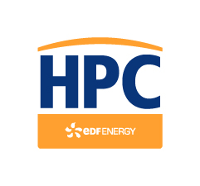
For office use only
Date received: | Ref No:

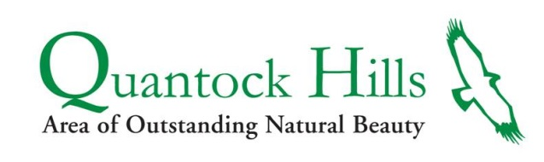
Delivered by:

GREATER QUANTOCK LANDSCAPE DEVELOPMENT FUND

Application form
Section A – Applicant details
Name of organisation
Contact name
Role/job title
(if applicable)
Address
Telephone
Email
Organisation status | Parish Council yes/no  Community/voluntary group or charity yes/no  Charity number if registered  Company/business yes/no  Company number (if limited)  Private/individual yes/no  Other- please define
Privacy Policy
Your personal data will be held and processed by Quantock Hills AONB Service (Somerset County Council), in accordance with the Data Protection Act 2018. SCC will use the information you have supplied to:
• administer your application to the GQLDF and contact you in regard to your application
• prevent and detect fraud or crime
Quantock Hills AONB Service will not disclose this information to any unauthorised person or body without obtaining your consent. Members o the public have a legal right to request your personal data held by SCC. A request for your personal data is called a Data Subject Access Request; please ring Somerset Direct on 0300 123 2224 for more details.
Voluntary groups should attach a copy of your constitution, details of your aims and objectives and membership. Others may wish to include a business or individual profile.

Section B – Project details
1 | Title | Detail here
2 | Location | Detail here
3 | Proposed Start date for project (approximate) | Date here
 | Anticipated completion date (approximate) | Date here
4 | Brief description | Description here
5 | What are you hoping to achieve and how? Explain both short and longer term aims
 | Aims and objectives here
6 | How does your project develop or enhance the landscape and who or what will it bring benefits to?
 | Landscape enhancement and benefits here
7 | How will your project be sustained in the future (e.g. maintenance)?
 | Maintenance here
8 | Is your project linked to other projects and/or strategies (e.g. Quantock Hills AONB Management Plan), if so, please give details
 | Other projects or strategies here
9 | Does your project benefit your local community and is there evidence of community support for your project?
 | Community support information here
10 | How are you going to measure and evaluate the project’s success?
 | Project outputs here, e.g. Xm of new hedgerow.
11 | Give details of any partners and explain their role

_________________________________________________________________________

Section C – Financial details

1. Please outline the project costs

Item or works | In- kind  (see guidance note) | Cash | Cost(£)
Total cost

2.
GQLDF Grant applied for £ | % of total cost

3. If you application is successful will you be able to reclaim VAT uncured in relation to costs covered by this grant? YES / NO

4. What other partners are you seeking financial support from (project income) either in cash or in –kind?

Name of organisation | Amount (£) | Cash or in-kind | Estimated or confirmed decision date

5. Have you obtained all the permissions you require to carry out the project? (eg planning permission, landowners consent, Forestry Commission, Natural England, Environment Agency approval, etc). If not, when do you expect to have each one agreed?

- Have you applied for other funding for this project, or previously received funding from the Landscape Development Fund or SDF?

_________________________________________________________________________

Section D – Applicant declaration

Please read and sign – I certify that I have been authorised by the organisation named in Section A to complete this application form. I certify that all information provided is true to the best of my knowledge. I understand that any materially misleading statements given at any stage during the application process could render the application invalid. I also understand that if the project is not completed the applicant may be required to return part or all of the money paid. I understand this application is not confidential and may be made available for inspection by the public.

This project complies with State Aid regulations.

Name _______________________________________________

Position in organisation________________________________
Date________________________________________________

Finally, for our information, how did you hear about the Landscape Development Fund?

Thank you for all this information – now please email to: quantockhills@somerset.gov.uk

PLEASE NOTE: Your completed application form should be a maximum of 6 A4 sheets using a minimum font size 10

Notification regarding the processing of any personal data supplied on this form

Data Controller – Somerset County Council
Data Protection Officer contact – informationgovernance@somerset.gov.uk
Purpose for processing – We collect and process your information for the administration and payments of grants under the Greater Quantock Landscape Development Fund. Date we process includes, your name, contact details and bank account details
Basis for processing your information –
Legal Basis – We must process your information in order to comply with the following statutory obligations - Accounts & Audit Regulations 2003, Local Government Act, HMPC Compliance Handbook Manual CH15400
Legitimate Interests – We will use your personal data in order to deliver a service to you, including provision of grant funding for eligible projects through the GQLDF.
Data Sharing – the personal data provided will not be shared with third party organisations.
Transfers abroad – this data will not be transferred abroad
Data Retention – this data will be retained for a period of 6 years to meet financial requirements
Your Rights – You have the right to ask Somerset County Council to a copy of your data, the right to rectify or erase your personal data, and the right to object to processing. However these rights are only applicable if the Council has no other legal obligation concerning that data. You also have the right to complain to the regulator, https://ico.org.uk/
Consequences: If you do not supply this information to us, we will not be able to process GQLDF applications and make payments of grants.
For more information see www.somerset.gov.uk/privacy

